Solutions Review
#1-8 Fill in the blanks with the vocabulary word to answer each question below:

Pairs of liquids that will not mix (example oil and water) are called _____(1)_____ liquids.

A solution with a concentration higher than the solubility is _____(2)_____.

Pressure has an appreciable effect on the solubility of ____(3)______ in liquids.

Pure gold is 24 carat. 14-carat gold contains 14 parts gold and 10 parts other metals. 14-carat gold is thus a solid solution called a(n) ____(4)_______.

A substance that dissolves other materials is a _______(5)________. The substance being dissolved is a _____(6)____________.

The three word phrase ____________(7)____________is a useful way to remember that polar substances can dissolve other polar substances and nonpolar substances can dissolve other nonpolar substances.

The process of dissolving is called _________(8)_________ and involves two steps: 1.) solute particles are surrounded by solvent particles and 2.) solute particles are pulled into solution.

#9-11 List three of the four ways to increase the rate at which a solid will dissolve in a liquid:

#12-20: Use the solubility curve below to help you answer the questions.
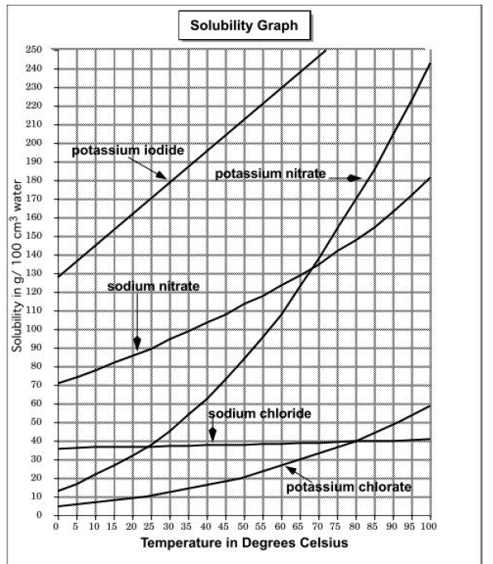
12. Which substance is most soluble at 60°C?

13. Which two substances have the same solubility at 80°C?

14. Which substance’s solubility changes the most from 0°C to 100°C?

15. If 50mL of water that is saturated with potassium chlorate at 50° is slowly evaporated to dryness, how many grams of the dry salt would be recovered?

16. What is the solubility of potassium nitrate at 90°C?

17. At what temperature does potassium iodide have a solubility of 150g/100cm³ water?

18. You have a solution of sodium nitrate containing 140g at 65°C. Is the solution saturated, unsaturated, or supersaturated?

19. You have a solution of potassium chlorte containing 4g at 65°C. How many additional grams of solute must be added to it to make the solution saturated?

20. A solution of potassium iodide at 70°C contains 200g of dissolved substance in 100 cm³ of water. The solution is allowed to cool. At what new temperature would crystals begin to start forming?

21. What is the percent by mass concentration of sodium bromide in a solution which contains 50.0g of sodium bromide in 200.0g of water?
- 40% b. 20% c. 25% d. 33%

22. A solution is prepared by dissolving 23.7g of CaCl₂ in 375g of water. What is the molality of the solution?
a. 0.214 b. 0.569 c. 5.7 d. 1.76

23. What is the molarity of a solution that contains 125gNaCL in 4L solution?
- 0.535M b. 2.14M c.8.56M d. 31.3M

24. What is the molality of a solution that contains 31gHCl in 5000g water?
- 0.062m b. 0.425m c. 0.170m d. 15.5m

25. A solution is made with 0.035L of rubbing alcohol and enough water to make 50.0mL of total solution. What is the percent by volume concentration of the solution?
a. 0.07% b. 70% c. 1.4% d. 7%

26. The molarity of a solution that contains 14gKOH per 150mL is
a. 93M b. 1.7M c. 0.093M d.11M

27. What volume of 1.25M HCl would be required to prepare 180mL of 0.5M HCl solution?
a. 450mL b. 72mL c. 0.014mL d. 2.2x10⁻³mL

28. How many moles of solute are present in 1.25L of a 0.75M NaNO₃ solution?
a.1.7mol b. 0.60mol c. 0.75mol d. 0.94mol

29. What is the molarity of a solution that contains 8 moles of solute in 2L of solution?
a. 4M b. 8M c. 6M d. 0.25M

30. To 225mL of a 0.8M solution of KI, a student adds enough water to make 1L of a more dilute KI solution. What is the molarity of the new solution?
a. 180M b. 0.18M c. 1.37M d. 10M

